Experiment Name:
Digital Project Management for Scientific Documentation with CLICK UP

Objective:
- To save people time by making the world more productive.
- To optimize the cycle of experimental analysis and documentation through digital project management.
- To reduce complex compilation time by breaking down complex documentation into manageable subtasks.

Theory:
- Click Up is a cloud-based collaboration and project management tool. It markets itself as "One app to replace them all." Its goal is to combine tasks, documents, chat, goals, and whiteboards into a single platform, so you don't have to switch between different apps (like using Trello for tasks and Google Docs for writing).
The Core Structure (The Hierarchy):
- Workspace: The top level.
- Spaces: High-level departments.
- Folders: Groupings within space.
- Lists: Containers for tasks.
- Tasks: The actual work items.

Required Equipment / Software:
- A computer with an internet connection.
- Click Up Account
- A text editor or IDE

Account Creation:
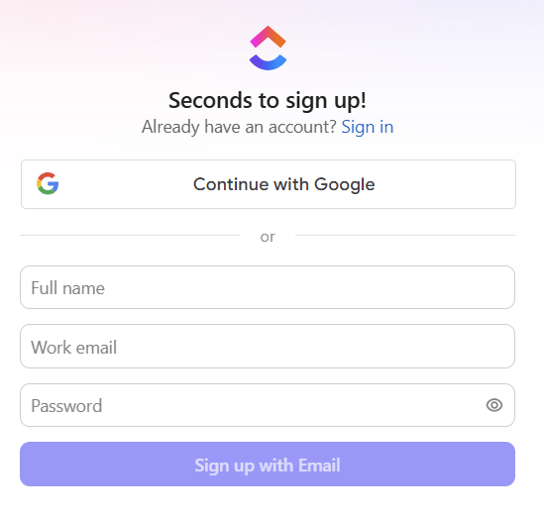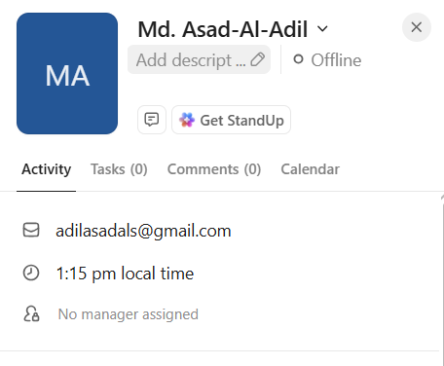
Setting up your ClickUp workspace is the first step toward better productivity. The account creation process is designed to be quick and intuitive:
- Sign Up: Navigate to the ClickUp homepage and enter the email address.
- Verify & Personalize: After verifying email with a 4-digit code, set up the profile. This includes choosing a strong password and uploading a profile avatar.
- Customize Workspace: ClickUp will ask a few onboarding questions to tailor the experience as our need.
- Template Selection: Based on answers, ClickUp suggests pre-built templates.
- Invite Team Members: Finally, one can invite colleagues or classmates via email to join our new workspace immediately."

Workspace:
The Workspace is the root container for all data in ClickUp. It functions as a completely self-contained environment.
- Isolation: Workspaces are separate entities. Data, settings, and tasks cannot be easily transferred between two different Workspaces.
- Multi-Workspace Access: A single user can belong to multiple Workspaces but they must switch between them to see the relevant tasks.
- Ownership: The Workspace holds the billing information and manages the global settings for all members and guests."

Team Space:
Spaces are the engine room of ClickUp because they allow for granular customization at the team level. Unlike the global Workspace, settings applied to a Space only affect the tasks inside it.
- Custom Statuses: Define the lifecycle of tasks specific to that team.
- ClickApps: Toggle features on or off per team. One can enable 'Sprints' for your Dev Space while keeping the 'Simple' layout for your HR Space.
- Privacy & Permissions: One can make Space public to the whole company or private to specific members, ensuring sensitive data remains secure.

Task Oriented Functions:
In ClickUp, a task is more than just a to-do item; it is a container for work. The lifecycle follows three distinct stages:
- Creation: Tasks can be created from anywhere in the workspace using the 'Quick Create' button. This is where you define the 'What' (Description, Attachments) and the 'When' (Start and Due Dates).
- Assignment: This defines the 'Who.' ClickUp allows for granular responsibility—you can assign a task to a single person, multiple members, or an entire Team. You can even assign specific comments within a task to ensure small details aren't missed.
- Completion: Marking a task as 'Complete' signals the end of the workflow. This action hides the task from an active view and updates the project's progress percentage automatically."

Professional Project Requirements
Requirement Analysis:
The process of determining, analyzing, and documenting exactly what a software system must do. It acts as the bridge between the client's vague ideas and the developer's technical code.
The Core Phases
- Elicitation (Gathering): talking to stakeholders, users, and clients to gather raw needs.
- Analysis: Refining those raw needs to spot conflicts, gaps, or ambiguities.
- Specification: Documenting the finalized requirements formally.
- Validation: Getting the client to sign off, confirming that the document matches their vision

Design Phase:
If Requirement Analysis is the Wishlist, the Design Phase is the Blueprint. This is where we stop asking what the software should do and start defining how it will do it.
- Architectural Design: Deciding the high-level structure.
- UI/UX Design: Creating the look and feel. Wireframes turn into high-fidelity mockups that show exactly where every button goes.
- Data Design: Structuring the database schemas and API endpoints to ensure data flows correctly between the server and the user."

Implementation:
Turning Design into RealityThis is the Build phase where the actual coding happens. Developers take the blueprints created during the Design Phase and translate them into executable software.
- Module Development: Programmers write code for individual units or components.
- Unit Testing: As code is written, developers perform 'White Box Testing' to ensure their specific block of code works correctly before merging it with the rest of the system.
- Integration: Individual pieces of code are combined to ensure they talk to each other correctly.
Delivery: The strategic phase of deploying the software to production servers, training the users, and ensuring the system is stable for the real world.
Workspace:
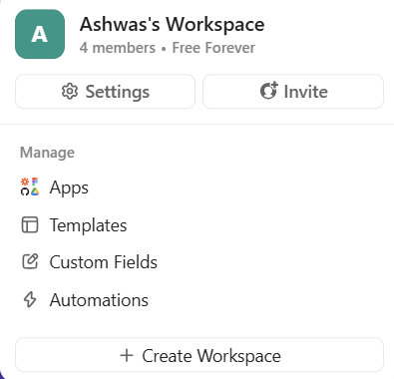
Team Space:
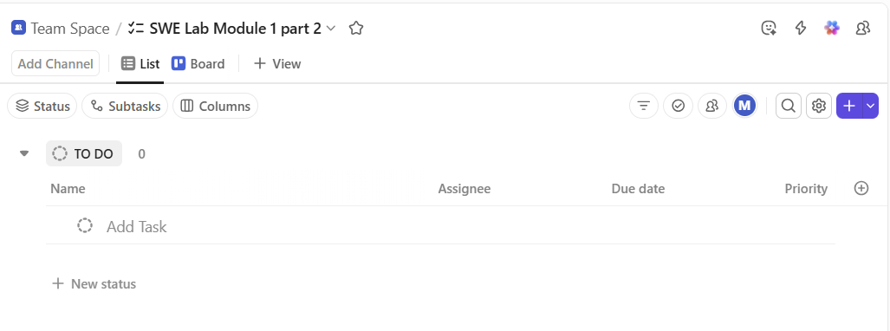

Task Creation:
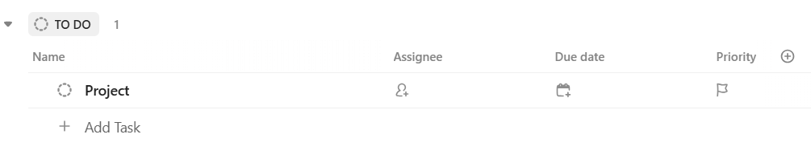

Task Assign:
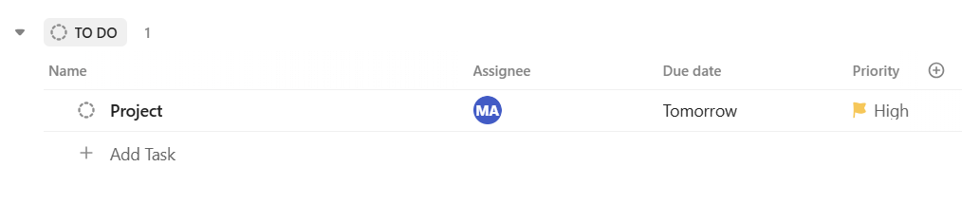
Task Complete:
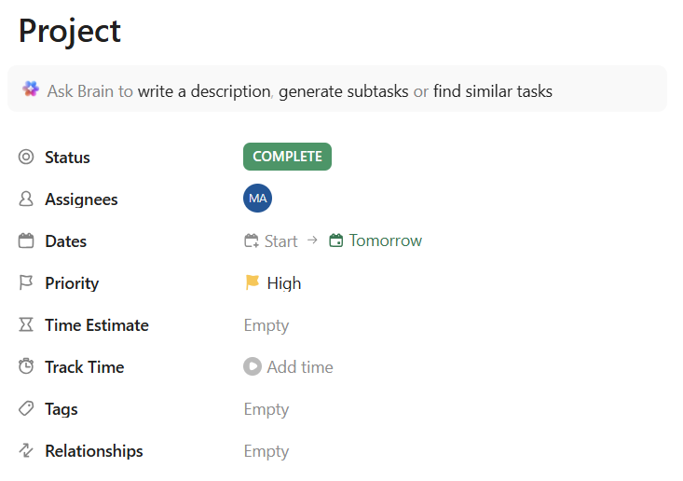

Requirement Analysis:

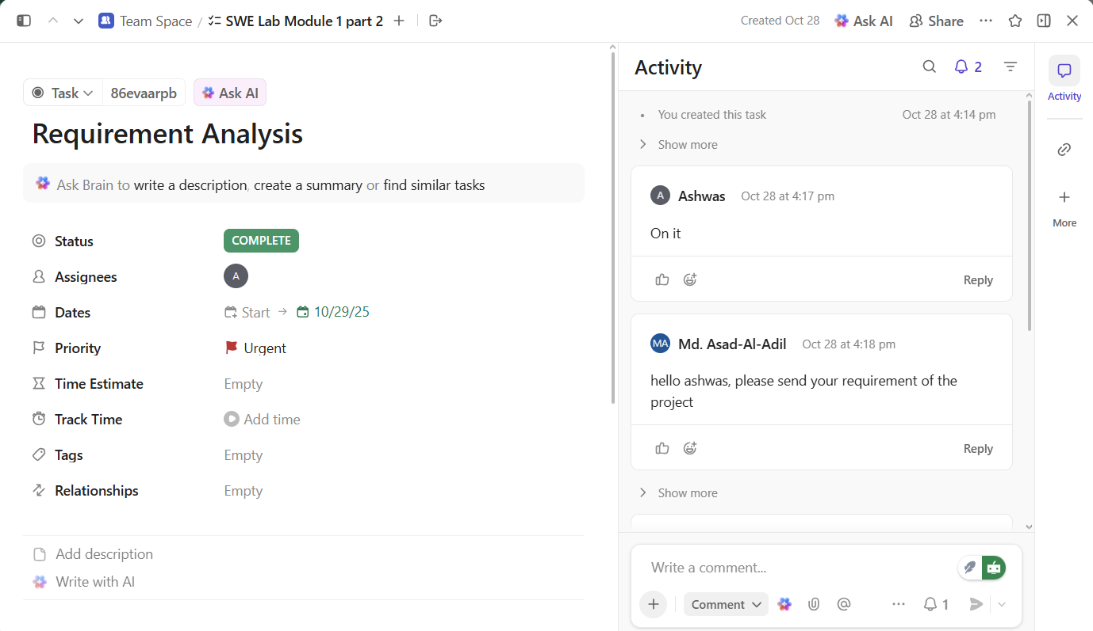

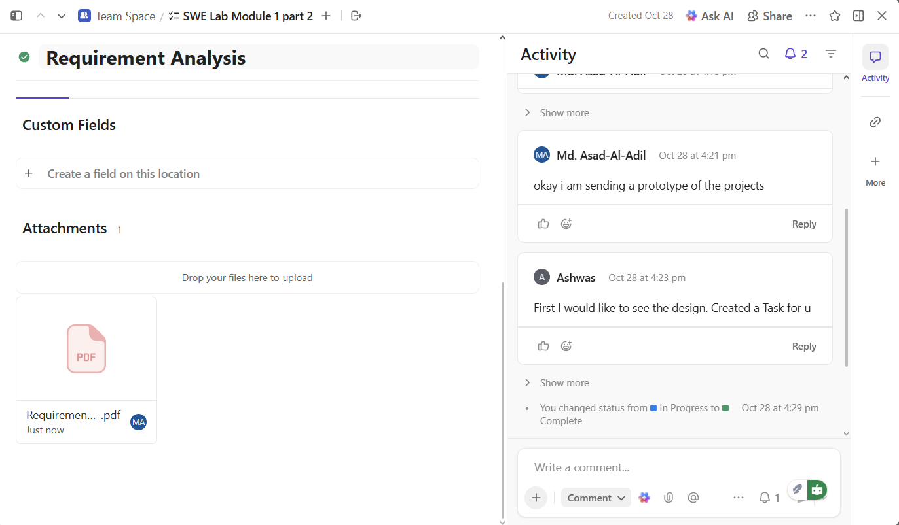

Design:

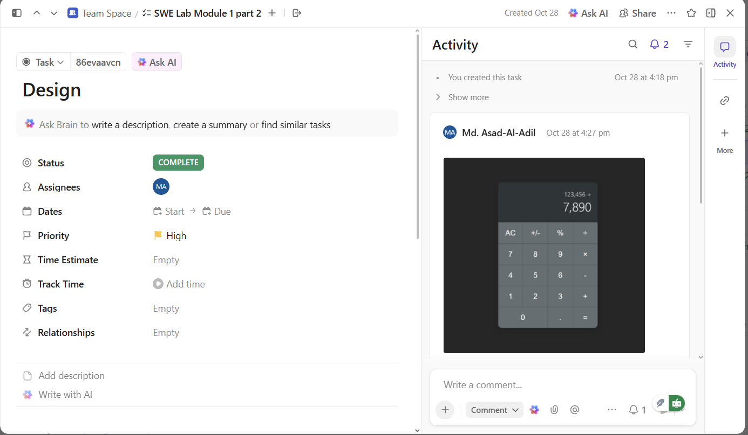

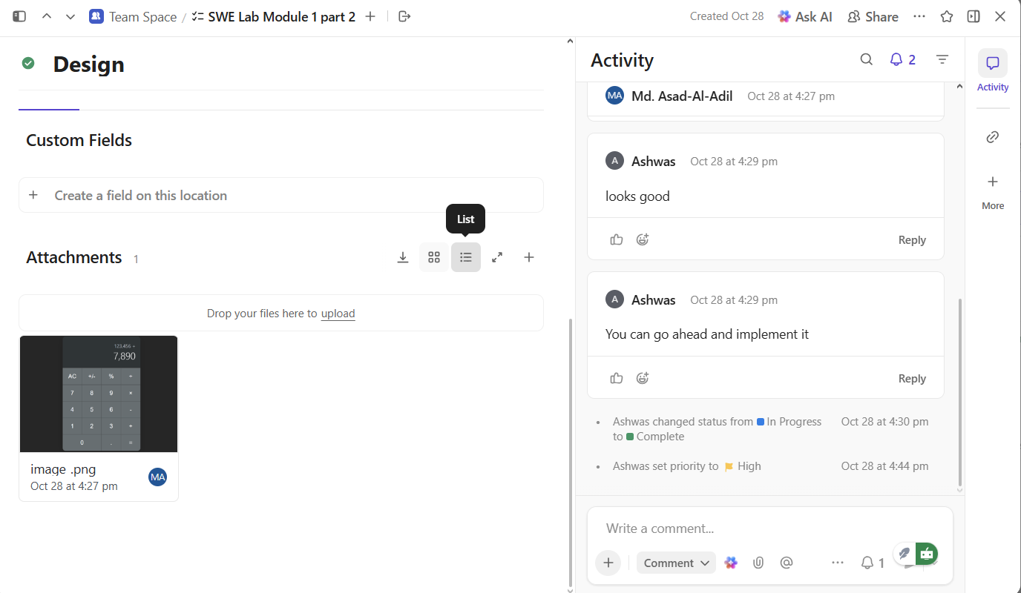

Implementation:
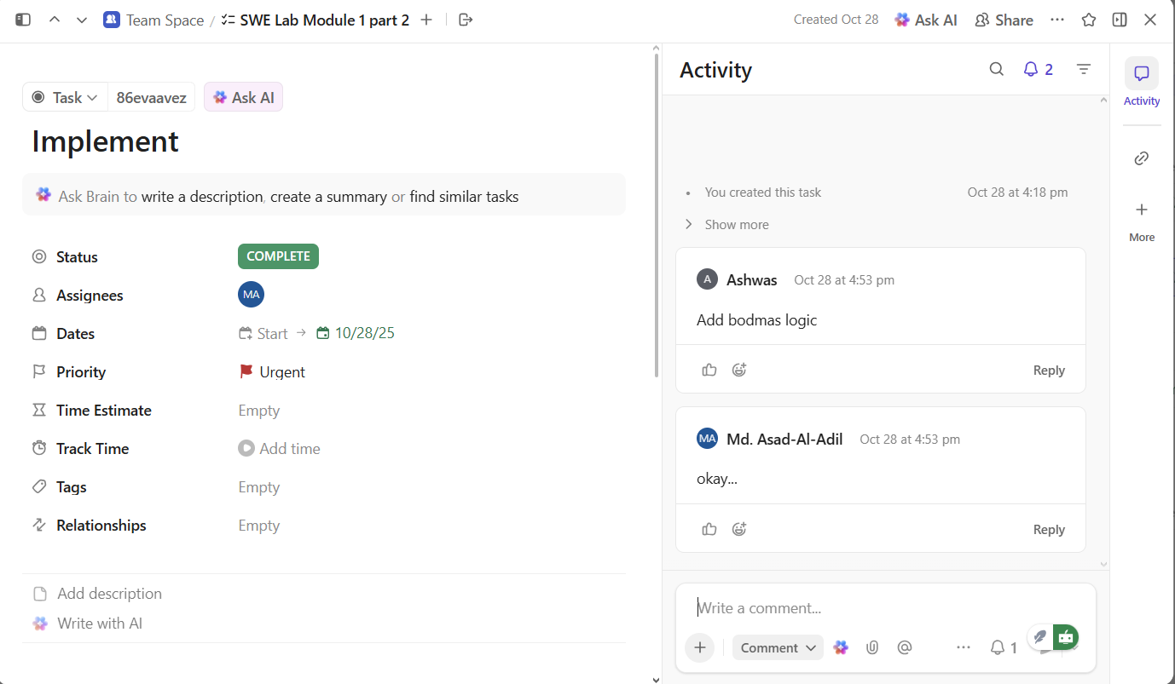
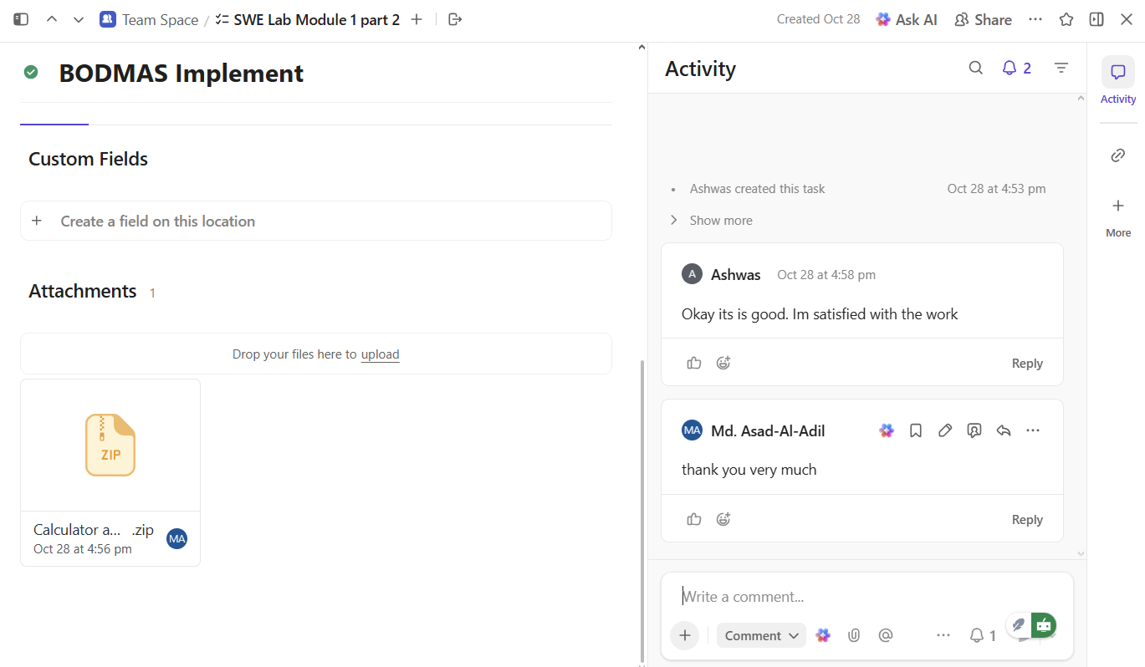
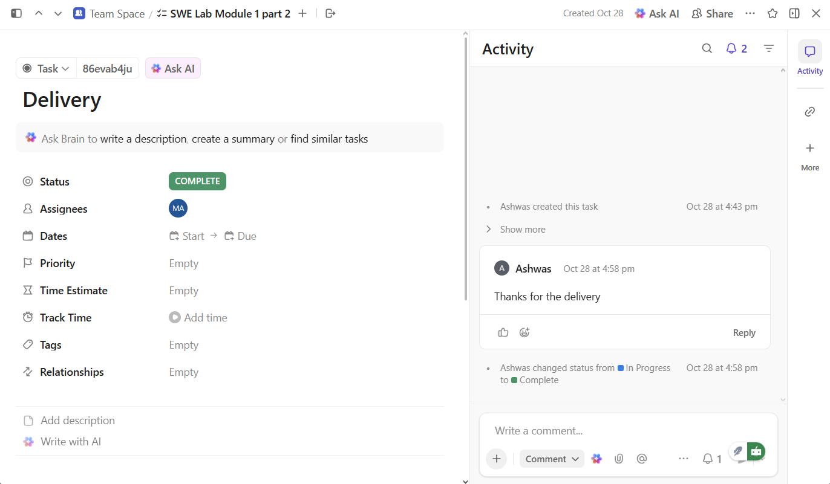

Completed Tasks:

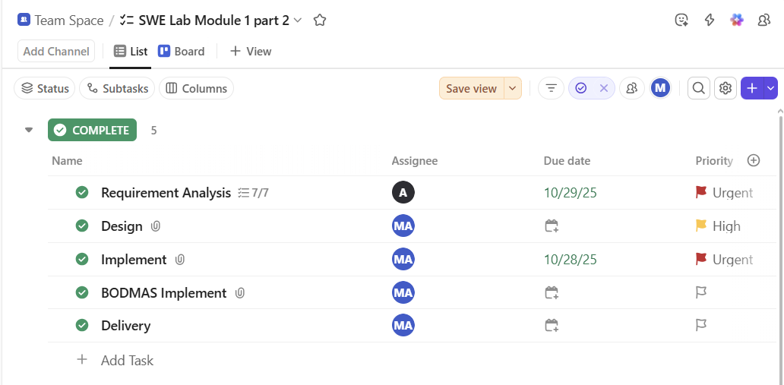

Conclusion:
ClickUp is the most flexible project management tool on the market today. Its mission to be the "one app to replace them all" is not just a moto—it genuinely combines the functionality of Trello, Asana, Google Docs, and Slack into a single ecosystem. It takes time to learn, but once one master it, it significantly increases productivity by keeping everything in one place.

